Activation: the function that acts on the weighted combination of inputs (and bias).

Heaviside activation function
Heaviside activation function: used in the perceptron when the output is not real but boolean (either 0 or 1). With np.heaviside(z, 1) we can specify what to do if the predicted output is exactly 0.

Φ(z) = ${\{ }_{1 if x < 0}^{0 if x > 0}$
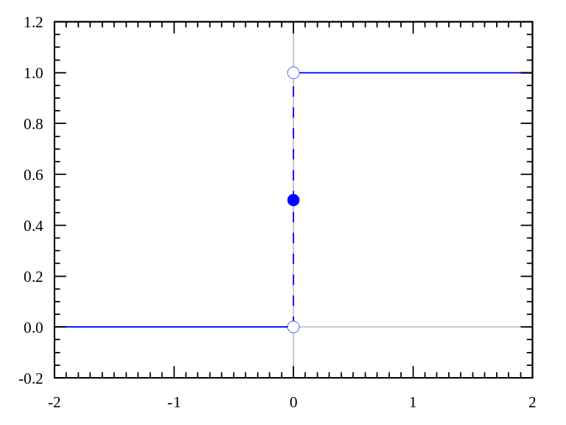

Sigmoid activation function
Sigmoid activation function: it is considered the counterpart of the heaviside activation function. Instead of a crisp activation, you have a smooth activation. It has range in the interval [0,1].

Φ(z) = $\frac{1}{1+e^{-x}}$

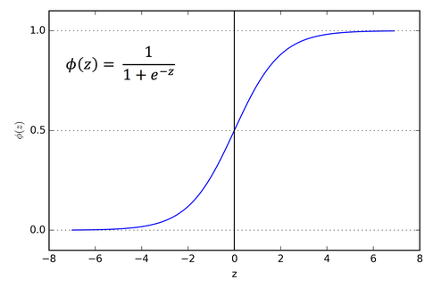

If it differentiable and it has as derivative:
Φ’(z) = Φ(z)(1-Φ(z))

Hyperbolic activation function
Hyperbolic activation function: it is very related to the sigmoid activation function, but it has a different range that is [-1,1]

f(z) = tanh(z)
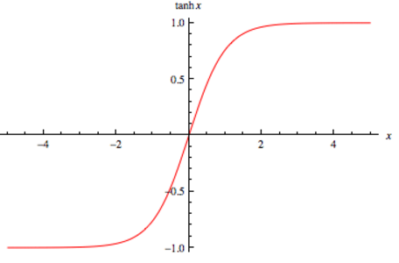

If it differentiable and it has as derivative:
f’(z) = 1 - f(z)²

Rectified Linear Unit (ReLU) activation function
Rectified Linear Unit (ReLU): it is an extension of the linear activation. It outputs 0 across half its domain. When z has a value that is negative the function will output 0.

f(z) = max(0,z)

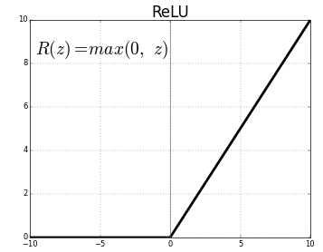

It has as derivative
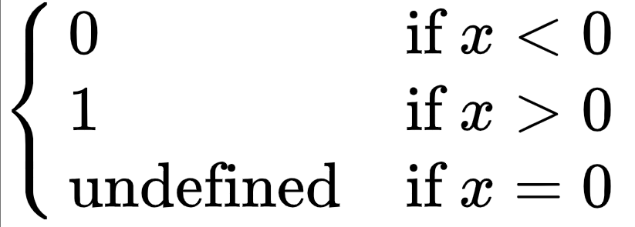

Softplus activation function
Softplus activation function: is a variation of the ReLU activation function, it is considered as a smooth version. It is not always 0 in the negative part.
f(z) = log(1 + e^{z})

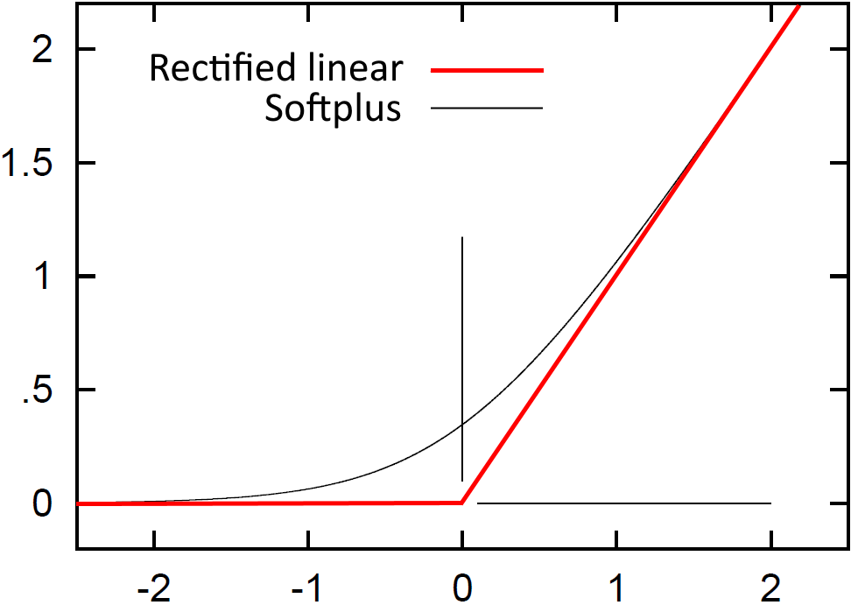

Leaky ReLU activation function
Leaky ReLU activation function: it is a variation of Rectified Linear Unit (ReLU). It is z when z is positive, and return αz when z is negative, where α is a small value (ex: α = 0.01)

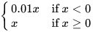
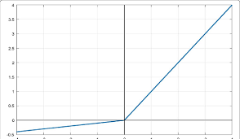

Softmax activation function
Softmax activation function: used for multiclass classification. If we have c different classes we will use c output neurons. Each output neuron represents a probability that the input instance can be classified as that specific class.

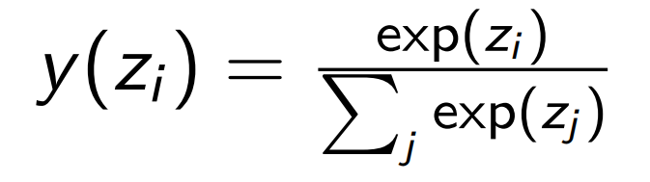

You take the exponential of your output of the neuron z_{i} and you divide by the sum of the output computed by the sum of all the other neurons. We have a vector as prediction

Lecture 01 - 08/03/2023
Lesson1.ipynb

Rosenblatt’s perceptron
- Originally proposed to model human retina sensory data
- All connections may be excitatory or inhibitory
- Association units combine sensory input with fixed weights
- Response units combine associative units with learnable weights

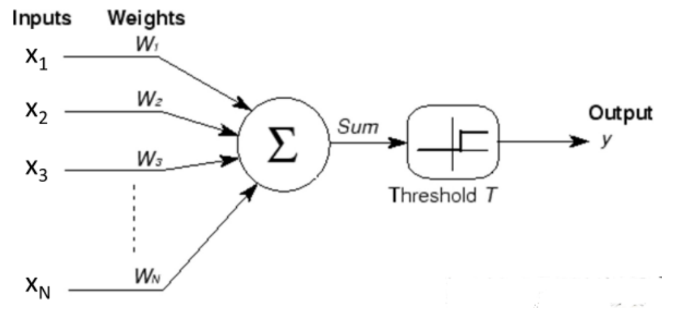

The inputs are x₁, x₂ x₃, …, x_{n} each one is connected with the computing unit (it is simplified with just one output neuron) and it is connected by a weight, the connection with the computing unit can be of different strength. The weights can also be negative.

In the original version of the perceptron the computing unit was summing all the input multiplied by the corresponding weight. After the sum is computer there is a signal that tells if the output (indicated by y) fires (value 1) or not (value 0).

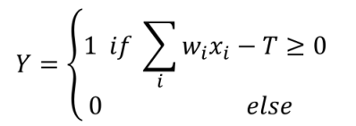
We have the threshold that compares the summation result with the threshold T. If the summation is greater or equal to the threshold then the neuron will fire (aka output 1). Otherwise (if the summation is lower than the threshold) the neuron will not fire (aka output 0.)

x = (x₁, x₂ x₃, …, x_{n}) is the input vector
w = (w₁, w₂ w₃, …, w_{n}) is the weight vector

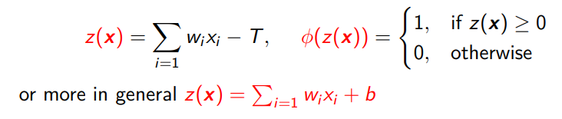
z is the summation of the input (times the weight) minus the threshold. More in general we can denote the summation function z(x) by using a linear term b (that can be either positive or negative).

The activation function is called Φ and it takes as values the summation, that is: Φ(z(x)).

Perceptron learning rule
This is how to change the vale of the weight

w = w + η(y(x) − Φ(z(x)))x

We compare the desired outcome y(x) with the outcome of the neuron Φ(z(x)).

w is equal to the previous value it had + a constant η multiplied by the difference of the desired output and current output

(remember: η is a scalar constant)

Example-01:
- Suppose that the desired output is 1, that is y(x) = 1 and the current outcome that we get is 0, that is Φ(z(x)) = 0.
Then in this case we have to increase w according to x

- Suppose that the desired output is 0, that is y(x) = 0 and the current outcome that we get is 1, that is Φ(z(x)) = 1.
The parenthesis is (0-1) and so it is negative, so we will decrease.

- If the desired output y(x) and the current outcome Φ(z(x)) are the same then the amount in parenthesis is exactly equal to 0 and so we do not update the weights

The perceptron cam mimics boolean gates
- X ^ Y (and)
- ¬X (not)
- X v Y (or)

But it can not mimic the xor (X ⊕ Y).

Limitations of perceptron
- Can not mimic the xor boolean gate
- Individual neurons are too weak
- We need more that one neuron
- We need more that one layer

This leaded to the Multi-layer perceptron

LAB1: Lesson1.ipynb

Lecture 02 - 10/03/2023
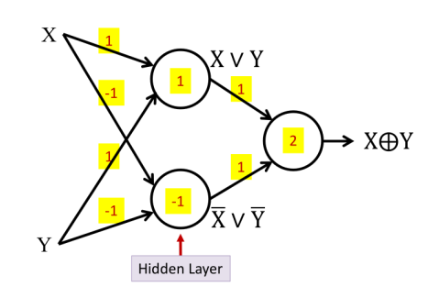

It is possible to represent (X ⊕ Y) using three perceptron.
Because by definition we know that (X ⊕ Y) = (X v Y) ^ ( ¬X v ¬Y)

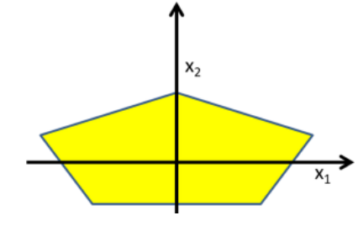

We can construct some more complex boundary regions. Each side of the pentagon is linear, so potentially we could use a perceptron for each side and combine them.

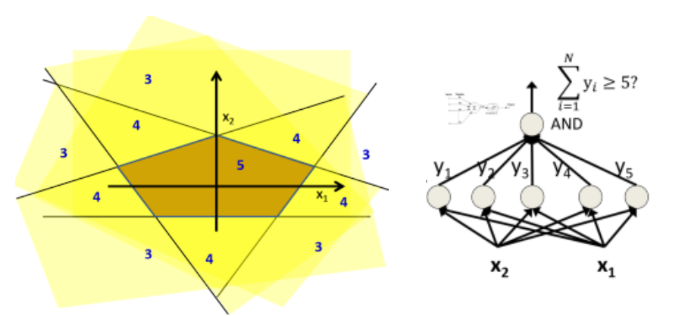
We have two inputs (x₁ and x₂) and each of them to the five perceptrons. Each point can fire in one or more perceptrons at the same time.

But the only region where all the five perceptrons fire at the same time is the pentagon. In all the other regions at least one perceptron is not firing. So we need an additional unit that receives all the output of the five perceptrons that fire only when all the five perceptrons are 1. We need to put an activation threshold at 5.

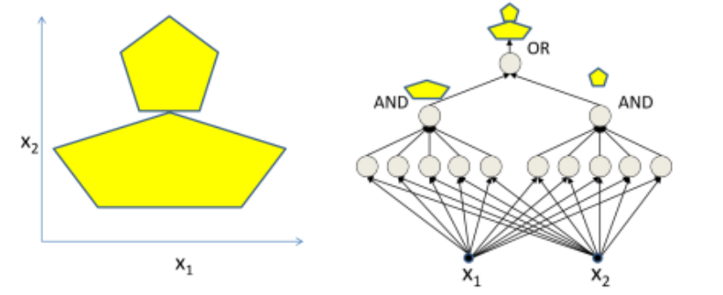
We can also incrementally compose very complex decision boundaries. But it might not be optimal, maybe we can reuse some perceptrons and get smaller in terms of the number of perceptrons and the number of weights.

Perceptron with real inputs and real outputs
We might have not only real inputs (and real weights), but also real outputs. To have real outputs we just need to change the activation function. In principle, the activation function can be any real function f: ℝ → ℝ. Furthermore if the function is differentiable we can train the weights appropriately.

Multi-layer perceptron (MLP)
Multi-layer perceptron: It is a network of perceptrons that are positioned at different levels and we have inputs that feed the first level of perceptrons, and then the output of the first level of perceptrons feeds the second level of perceptrons and so on.

Deep neural networks: we mean something that has an input and an output and many hidden layers (is not important if they are a perceptron or other algorithm). We also usually consider “deep” a network with at least two hidden layers.
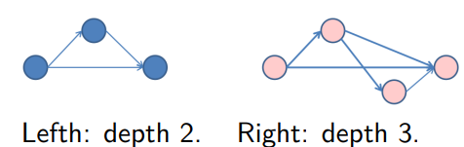

Length: number of edges we find in the longest path connecting an input to the output neuron (of course it must have directed edges).
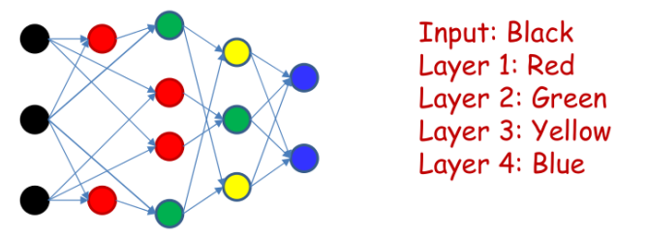

Layer: set of neurons that are all at the same depth with respect to the input.
Also inputs can even appear in different layers, it is not mandatory that we need to have one input layer, we might have different levels.

A neural network can be considered to be just a function that given one or more inputs it computes the function to predict one or more outputs.

In a multi-layer perceptron inputs and outputs are real or boolean stimuli. But we can have multiple outputs for a single input. It can also compute any Boolean function; they are said to be a universal Boolean function. The more complex the Boolean formula, the more complex the network.

One hidden layer in MLP is enough to represent any boolean function. The complexity of the MLP does not grow linearly with respect to the formula, the number of perceptrons needed can grow exponentially.

We quantify the complexity of a network considering:
- The number of layers in the network
- The number of neurons
- The number of parameters (connections + bias) ⇐ the most exact definition

How to decide the depth and the number of perceptrons in MLP
We do not have a way to decide the optimal architecture for our network to solve a given problem. We have some practical rules to help us:
- A one-hidden-layer MLP realizing a boolean function of N input Boolean variables may require 2^{N-1} perceptrons in the hidden layer
- Deeper networks may require far fewer neurons than shallower networks to express the same function ⟹ even if by using one hidden layer we can do the same thing of more hidden layers but using more hidden layers can make our network less complex. We can have different way to realize the same function

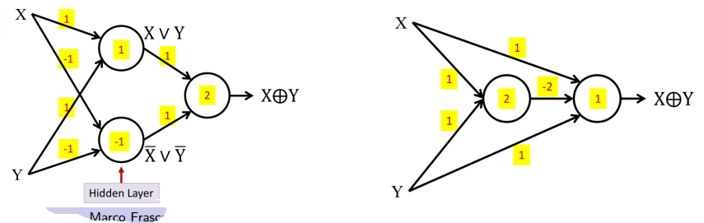
For the xor the method on the left uses only two perceptrons. But it is exactly the same function. We can simpler and more complex multi-layer perceptrons.

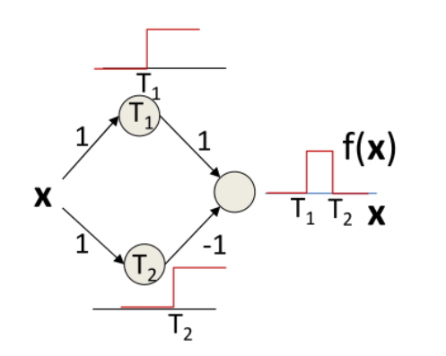
Given a certain function/curve in our output shape, the perceptron can approximate (but we can approximate very well (but it is more complex) or badly (but it is easier), there is always a tradeoff). With three perceptrons ( ! the last one has threshold set to 1) this network can describe the f(x) complex shape _∏_ (before t₁ and after t₂ it is 0, and between t₁ and t₂ it fires). The only case in which the output neuron will fire is when we have an x that is between t₁ and t₂.

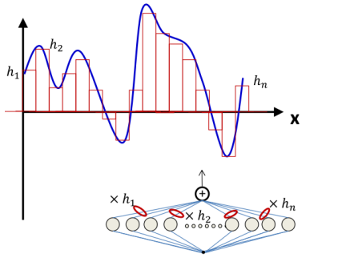
From what we saw right now, given a desired output shape we can construct a lot of similar bars that will describe exactly the curve. (it is somehow similar to the idea of integration: when you want to find the area under the curve you construct a lot of rectangles). In principle, we can make the rectangles as narrow (more exact) as we want. This is why the MLP is considered an universal approximator.

Multi-layer perceptron are:
- Universal boolean function
- Universal classifier
- Universal approximators

When we face very complex problems whose shape is not exactly known, we will implement an approximator and we will hope that we are approximating in a good way. We try to design our architecture in order to approximate our problem better and better.

Lecture 03 - 08/03/2023
Lesson3.ipynb

In the multi-layer perceptron (MLP) the more layers you have the more values you have to train because each layer has its own dedicated connection.

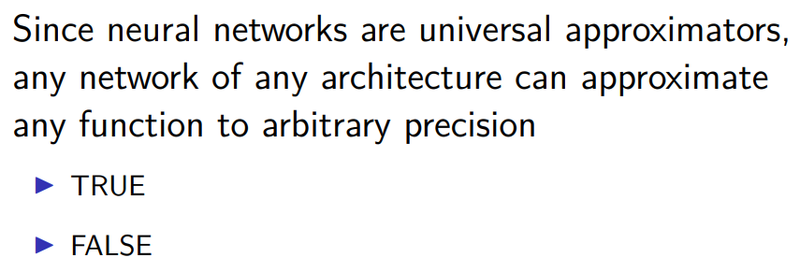
POOL 1:
Solution: It is false, a single perceptron is not able to model the pentagon region. In order to approximate to any arbitrary precision a given function we need to model a suitable architecture. We need a suitable architecture.

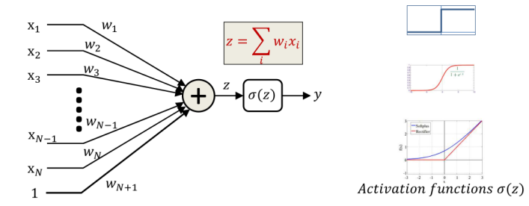
We can consider the bias as an additional input whose value is always 1 and the bias corresponds to the weight that is W_{N+1} and so we can z (the summation of the inputs) without summing later the bias. Also if the bias is not explicitly mentioned we assume every perceptron has an additional input that is always fixed at 1.

(remember: the parameters of the perceptron that determine how it behaves are its weights and biases).

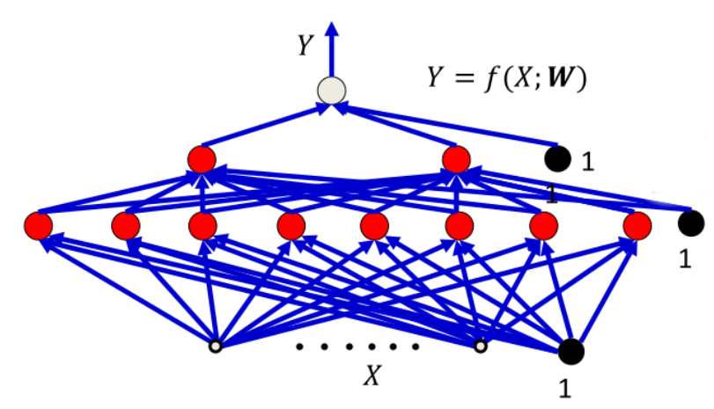
We have to learn the weights and the bias for all the units. So we can see that we can see the network as a function f that depends on the inputs X but also on the parameters that we have to learn (aka W), that is:

f(X, W)

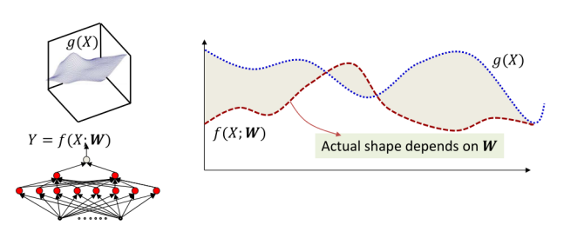
Output function g(X) (in blue), and given an assignment to the weight W for any input X it outputs Y (the function in red) that we have to compare with g(X). The bigger the shaded area the more inaccurate is our network, we need to find the W that decreases as much as possible the shaded area.

The shaded area is:
Err(W) = $\int_{-∞}^{+∞}{}$error( f(X, W), g(X) ) dX

The criterion to find the optimal (best) W is:

$\hat{W}$ = arg min_{w} Err(W)

Find the argument that minimize the error W

Problem: usually the function g(X) is not fully specified everywhere, so g(X) is not know, and so we can not compute perfectly Err(W), but we can do an approximation of g(X)

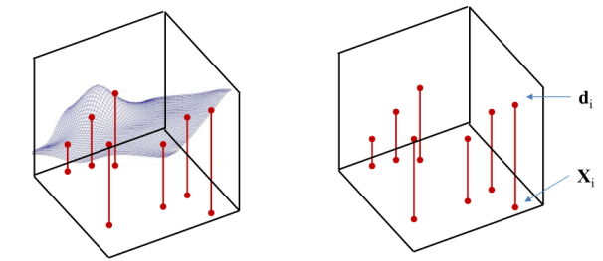
We sample some points of the function g(X). d_{i} can be assumed to be equal to g(X_{i}). We must learn the entire function from these few examples. Our goal is not anymore to find $\hat{W}$ that minimize the error, we will minimize the empirical error.

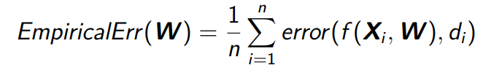

The EmpiricalError(W) is defined as the average error on the training sample. We do not have g(X) but we have some sample and we try to estimate the error by computing the empirical error, that is the error that our network does on the training example. It is typically referred also to as Loss function.

From this our optimal weight will be those that minimize the empirical error W (and not the error (W).

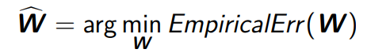

Problem: we are making an assumption that might not work (but we can not do differently). We know the true label of some samples, but not of all the samples. We do not have the guarantee that all the input that we do not have in the training is good.

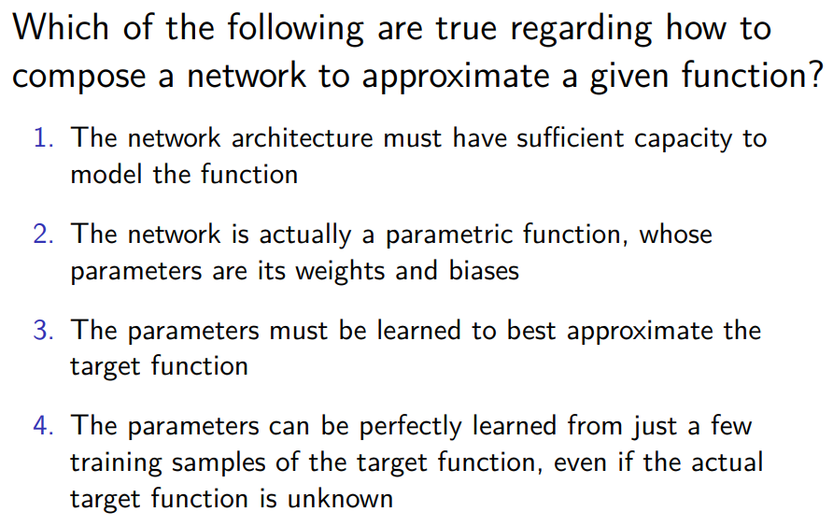
POOL 2:
Solution: 1-2-3 are true. The 4 is false because the parameters can not be perfectly learned from a few samples.

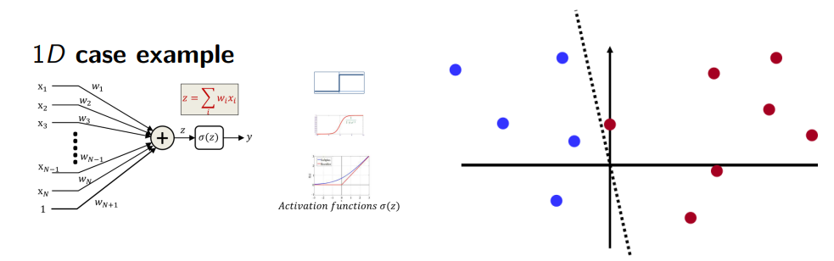
When the summation $\sum_{i=1}^{N+1}{}$w_{i}X_{i} is bigger than 0 then the neuron will fire. It will not fire if it is lower than 0. We need to find the hyperplane that perfectly separates the two types of points.

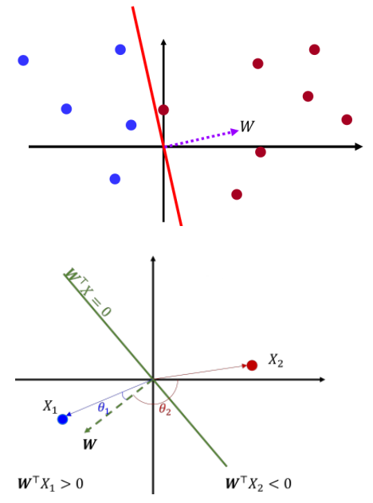
W^{T}X = 0 means that the two vectors X and W are orthogonal to each other.

The set of all X that are orthogonal to W forms a hyperplane: the classification boundary.

W points in the direction of the positive class. By definition W^{T}X = |X| |W| cosθ.

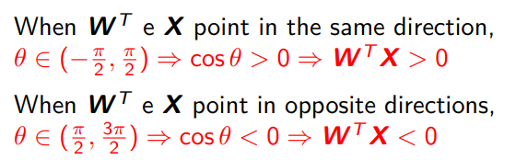

Thus the problem of finding the perceptron, given these data samples, is that of finding the hyperplane that exactly separates the two sets of sample points.

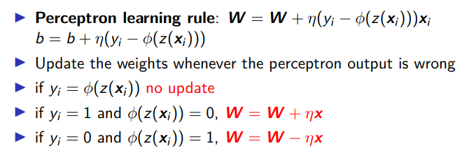

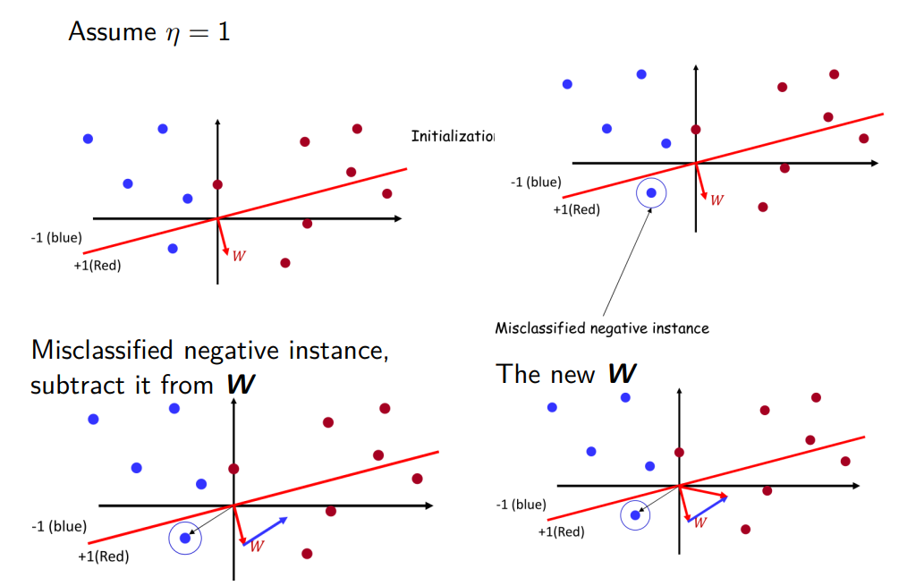
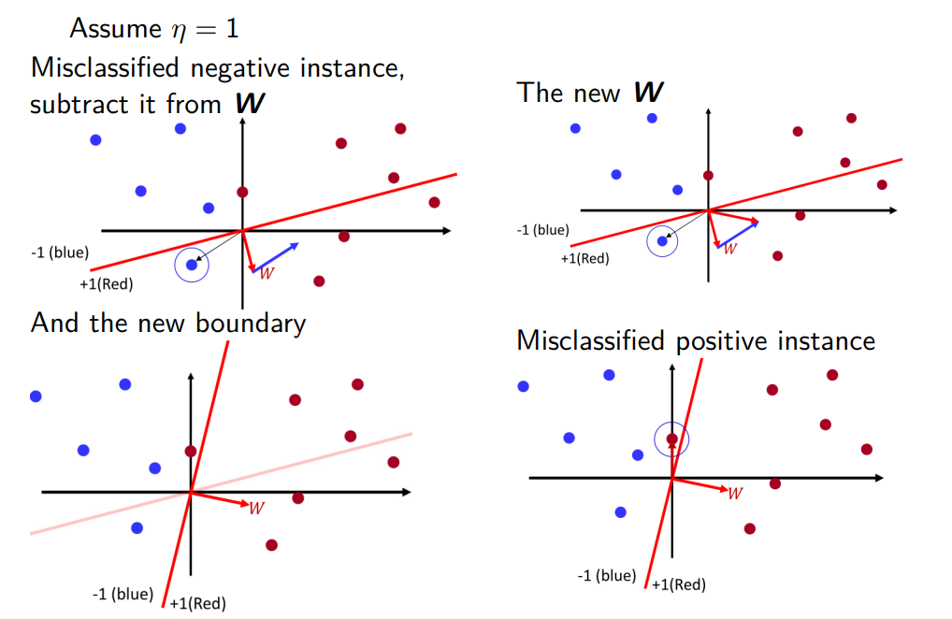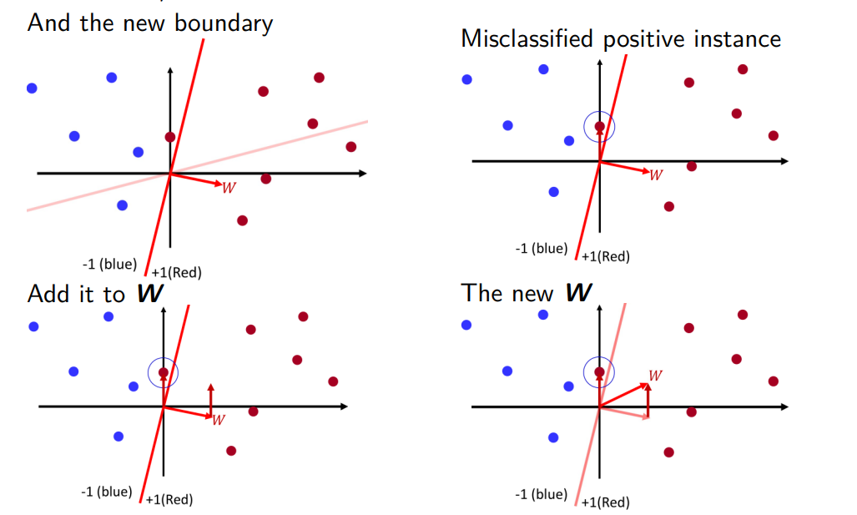
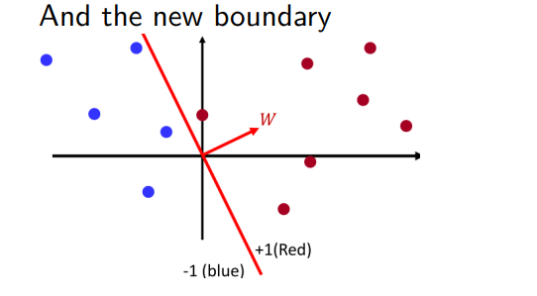

Now there is no misclassification, we have a perfect classification. No more updates. But we can get a perfect classification with the perceptron only when the points are linearly separable. When the classes are not linearly separable it is not possible to find a separating hyperplane, some points will always lie on the other side, and the perceptron algorithm will never converge.


Problem with learning in the MLP: the training data only specifies input and output of the network, the intermediate outputs (the outputs of the hidden layer) are not specified and so we can not do the training. Training this network using the perceptron requires to determine the correct output for each neuron and each instance.

Adaline
We have Adaline: it is a simple extension of the perceptron. The difference between Adaline and Perceptron is in the learning rule. With Adaline the weighted sum of inputs and bias (called z) passes through a Heaviside function.

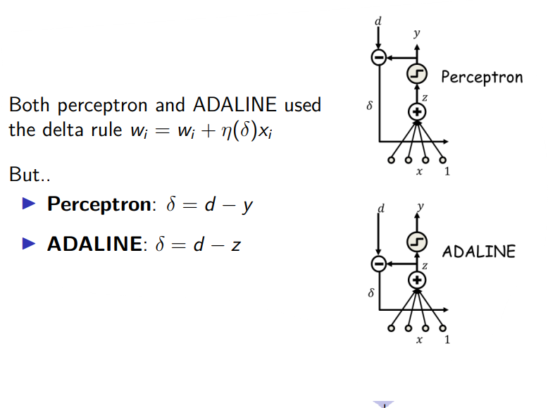

LAB3: Lesson3.ipynb

Lecture 04 - 17/03/2023

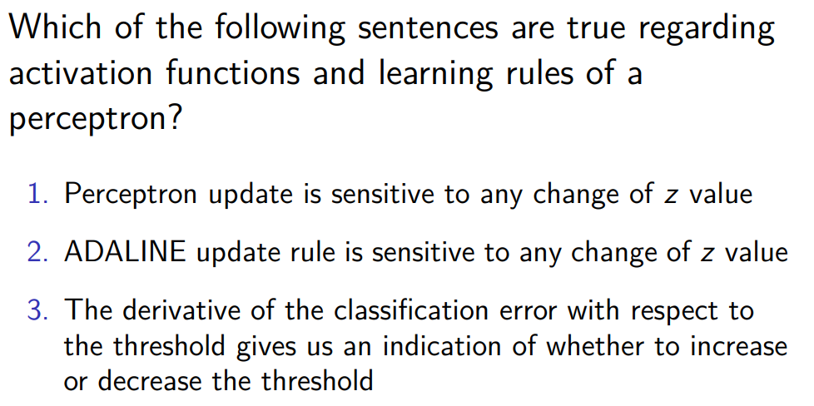
POOL 3
Solution: first one is false, is not sensitive to any change of z value, if it is 0.75 or 0.9 it will still output 1. N.2 is true, Adaline updates the weights not by considering the final output of the perceptron but considering z. N.3 false, the derivative of 1 is 0. Does not give us any indication on how to change.

Remember:
- The perceptron rule is not suitable to train MLPs
- Heaviside function has 0 derivative always, except for z=0, where it is not differentiable
- No capability to distinguish small differences of z value
- Need real-valued differentiable activation function

Madaline (multiple Adaline)
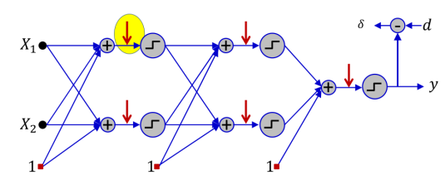
Are several perceptrons with different activation functions.

Suppose we have a set of training instances (that is the input vector) and we have the desired output (usually called d). Like for the perceptron we take the output produced and we compare it to the desired output d. With madaline (as well as with the perceptron) we do not change anything if there is no misclassification (if it is correct we don’t modify anything). Instead when we have misclassification we look at all the perceptrons in our model and we find the neuron which requires the smallest perturbation to flip its output (of the single perceptron) and at the same time it flips the output of the network. With madaline we have a lot of possible updates to do. Once we find the neuron we use the least square update (LSU)

It is a greedy training algorithm. It is effective for small networks 🙂, but is not very useful for large nets:
- Too expensive (need to compute all the possibilities) 🙁
- Too greedy 🙁
- Easily gets stuck in local minima. Not guaranteed to find the best solution. 🙁

Probability of firing:
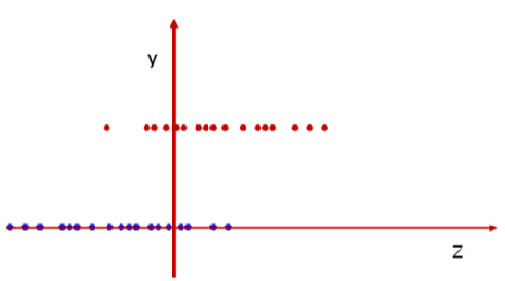
The red dot belongs to the positive class (y=1) and the blue one to the negative class (y=0). In this case z values can not perfectly discriminate these two classes (the red dot alone will be classified as part of the negative class, same for the blue dots that would be classified as positive).

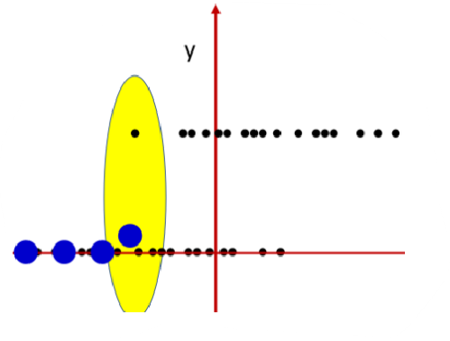

We can check how many positive and negative points are in a small region (the yellow one). We represent with the big blue dot the probability of being in the class 0 or 1, it is a sort of average.

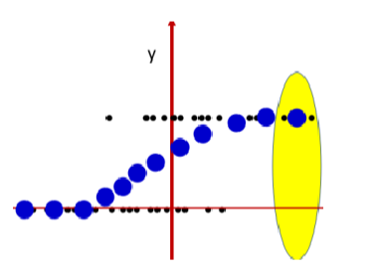

We can see that from the disposition of the items when we move from left to right the average increases. This is the logistic regression model (sigmoid function).

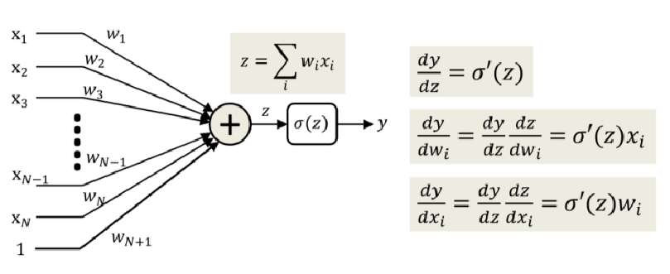
The sigmoid function is differentiable everywhere. Now we can update the weights by using the first derivative. The first derivative gives to you an information on how much your function would change when you have a small change in the input.

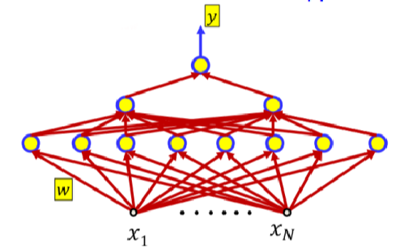
If we move to MLP each perceptron has a real and differentiable activation function and so, by extension, the overall network MLP will have an output that is differentiable.

Using the chain rule we can compute how small perturbations of a parameter change the output of the network.

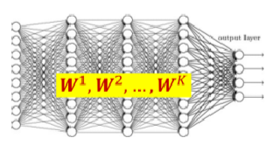

In a MLP we have many hidden layers and each layer has a corresponding weight matrix.

It is a matrix because each output unit is connected to all the inputs. If you have multiple output units you have multiple weight vectors (that is a matrix). As an example, between the first and second layer we have n inputs and n outputs and each of the n inputs is connected to each of the n outputs so we have n×n connections (that is a matrix).

Each input neuron i for layer k is connected with any output neuron j layer k (weight w^{k}_{ij})

Net: the output of the network on a given input X^{(i)} (it is the vector of inputs). The net depends also on the weights in each of the layers that compose the MLP. W^{(k)} is the weight matrix for the hidden layer that has index k.

Our loss will not be of just an individual W but of all the W that we have in our network.
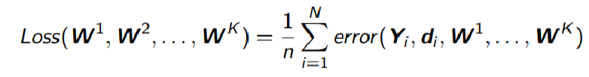
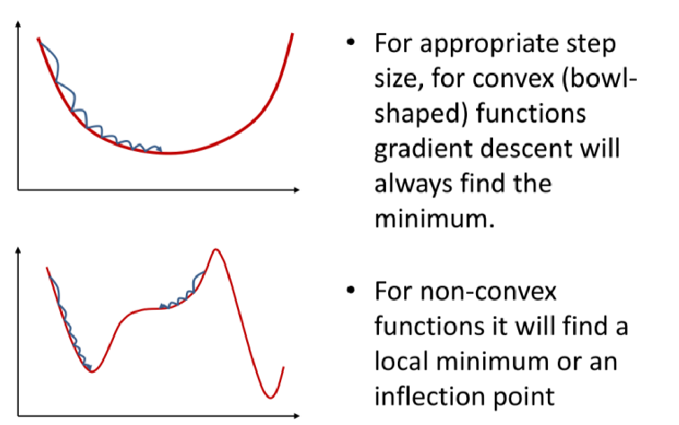

Lecture 05 - 22/03/2023

Recap:
- Output layers might have multiple output units
- Each unit has a continuous and differentiable activation function
- A loss function measures the overall “error” on a given training set
- Objective. find the weights that minimize the empirical error

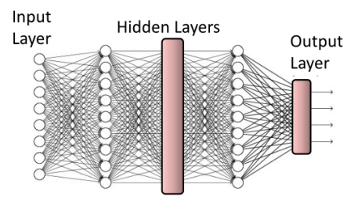
We might have an output layer that might contain a single individual neuron(=unit) or more then one. If we have more than one unit each unit will output its own value, and we can consider the output value as components of a vector. So the network will take as input a vector and it will output another vector.

Technically the change in one input will potentially change the output. Just one change might affect the output of any neuron.

When you have a multiclass classification the idea is to use a softmax activation function.

Binary classification: which activation?
If the desired output is binary ( cat(1) or not cat(0) ) use a simple 1/0 representation of the desired output (typically a sigmoid)

- If labels are in [0,1] sigmoid is perfect
- If labels are in [-1,1] tanh is preferable
- If labels are in another range [0,N] we scale/normalize labels to [0,1] or we can use another activation function ReLU

min 42 lez 5.1

riprendere 5.1 min 22.10

Differentiable: a function whose derivative exists at each point of the domain
To solve an optimization problem it divides the problem in subproblems and for each part it chooses a solution that is optimal. Always choose something that is locally the best for me

